# Building connections on LinkedIn

## **Using LinkedIn to connect**

A **connection** is someone you know and trust on a personal or professional basis. Your connections are who make up your network. And when it comes to your network, it is important to remember quality over quantity. So don’t focus on how many connections you have. Instead, make sure that everyone you connect with adds value to your network, and vice versa.

## **Inviting those you know versus making cold requests**

Adding connections on LinkedIn is easy. You invite people to join your network, and they accept your invitation. When you send an invitation, you can attach a personal note. Personal notes are highly recommended.

A great way to increase the number of your connections is to invite classmates, friends, teachers, or even members of a club or organization you are in. LinkedIn also gives suggestions for connections based on your profile information. Here's an example (template) that you can use to connect with a former co-worker:

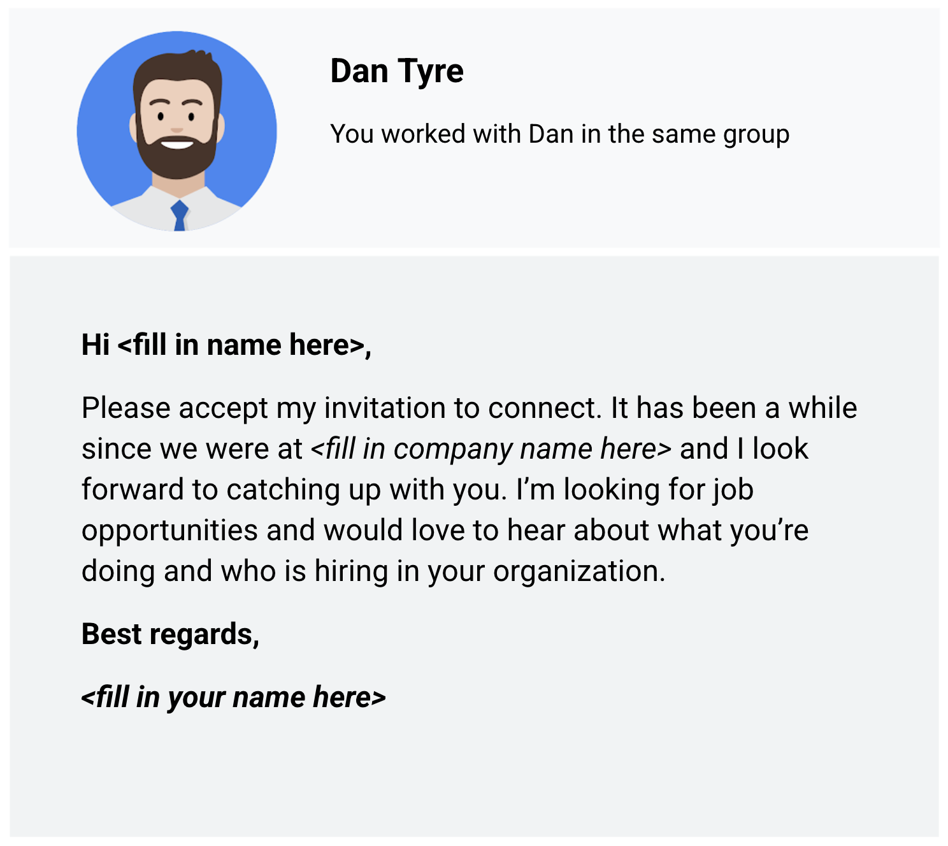

The message:

Hi <fill in name here>,

Please accept my invitation to connect. It has been a while since we were at <fill in company name here> and I look forward to catching up with you. I’m looking for job opportunities and would love to hear about what you’re doing and who is hiring in your organization.

Best regards,

<fill in your name here>

Cold requests on LinkedIn are invitations to connect with people you don’t know personally or professionally. When you start to build your network, it is best to connect with people you already know. But cold requests might be the only way to connect with people who work at companies you are interested in. You can learn a lot about a company’s culture and job openings from current employees. As a best practice, send cold requests rarely and only when there is no other way to connect.

## **Asking for recommendations (references)**

Recommendations on LinkedIn are a great way to have others vouch for you. Ask people to comment on your past performance, how you handled a challenging project, or your strengths as a data analyst. You can choose to accept, reject, show, or hide recommendations in your profile.

Here are some tips for asking for a recommendation:

* Reach out to a variety of people for a 360-degree view: supervisors, co-workers, direct reports, partners, and clients
* Personalize the recommendation request with a custom message
* Suggest strengths and capabilities they can highlight as part of your request
* Be willing to write a recommendation in return

Read the recommendation carefully before you accept it into your profile

Sometimes the hardest part of getting a recommendation is creating the right request message. Here's an example (template) that you can use to ask for a recommendation:

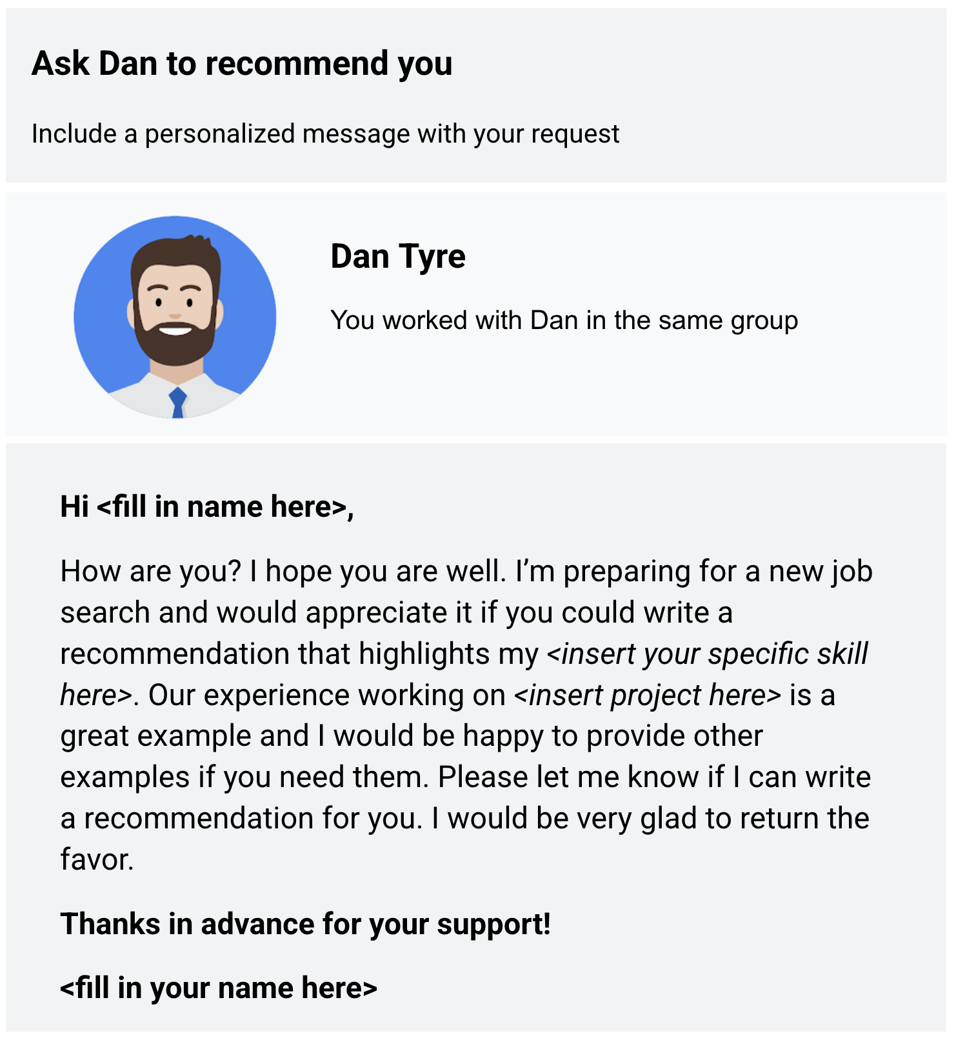

Hi <fill in name here>,

How are you? I hope you are well. I’m preparing for a new job search and would appreciate it if you could write a recommendation that highlights my <insert your specific skill here>. Our experience working on <insert project here> is a great example and I would be happy to provide other examples if you need them. Please let me know if I can write a recommendation for you. I would be very glad to return the favor.

Thanks in advance for your support!

<fill in your name here>

Ask a few connections to recommend you and highlight why you should be hired. Recommendations help prospective employers get a better idea of who you are and the quality of your work.

## **Summing it up**

When you write thoughtful posts and respond to others genuinely, people in and even outside your network will be open and ready to help you during your job search.

Consider Kaggle’s community features and how you might use social media yourself:

* How might you use interactive notebooks and the data community on Kaggle to elevate your career?
* How can you use Kaggle to help improve your social media impact and meet your professional goals?
* Imagine your ideal data analyst social media presence. What would you like to put on your profile? What kind of engagement would you like to receive from other people?

Reflect on your professional social media goals and think about how you can use Kaggle to establish your online presence.

Now, write 2-3 sentences (40-60 words) in response to each of these questions. Type your response in the text box below.

* Interactive notebooks and data community on Kaggle can help demonstrate skills and lead to job opportunities or collaborations.
* Kaggle can be used to establish an online presence and connect with other data professionals to improve social media impact and meet professional goals.
* An ideal data analyst social media presence on Kaggle would include showcasing projects and accomplishments, sharing insights and receiving engagement from the community.
* Using Kaggle to showcase skills and connect with other data professionals can establish an online presence and meet professional goals.